**Task 1: Create a Linux VM and Install Apache 2**

1. **Log in to the Azure Portal:**
   * Go to [Azure Portal](https://portal.azure.com).
2. **Create a Virtual Machine:**
   * Click on "Create a resource" > "Compute" > "Virtual Machine."
   * Fill in the necessary details:
     + **Subscription:** Choose your subscription.
     + **Resource Group:** Select an existing resource group or create a new one.
     + **Virtual Machine Name:** Provide a name for the VM.
     + **Region:** Select the desired region.
     + **Image:** Choose a Linux distribution (e.g., Ubuntu 22.04 LTS).
     + **Size:** Select the appropriate VM size based on your needs.
     + **Administrator Account:** Provide a username and SSH public key or password for access.
   * Configure any additional settings as needed, then click "Review + Create" and then "Create."

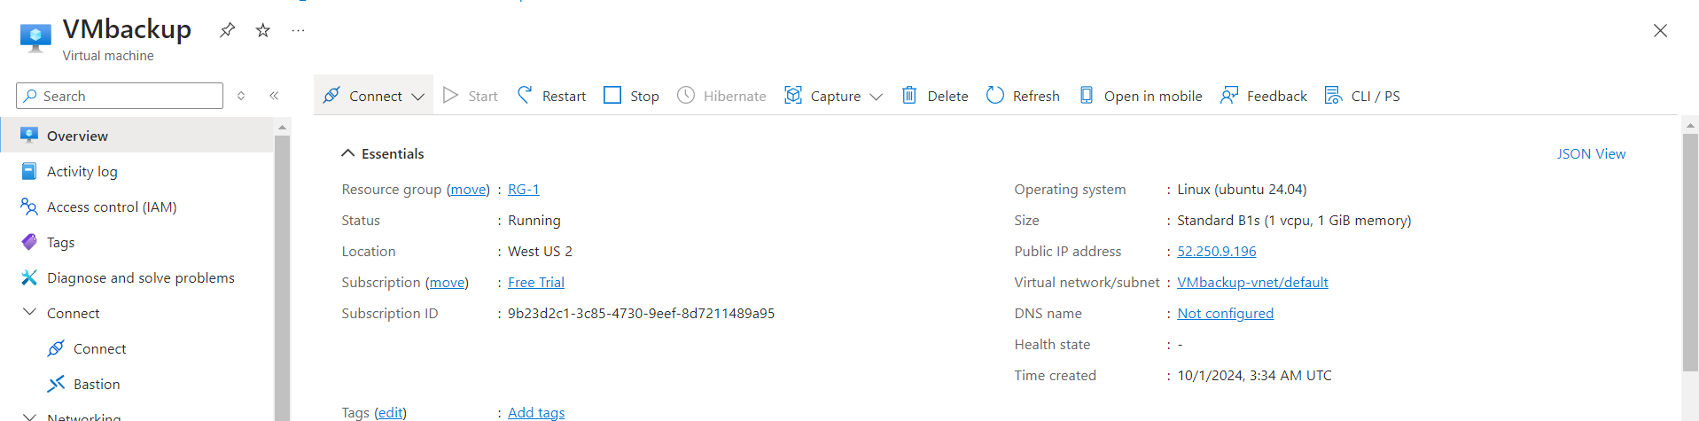

1. **Connect to the VM:**
   * Once the VM is deployed, go to the VM's overview page and click "Connect."
   * Use SSH to connect (for Linux) with the following command:

**ssh <username>@<public-ip-address>**

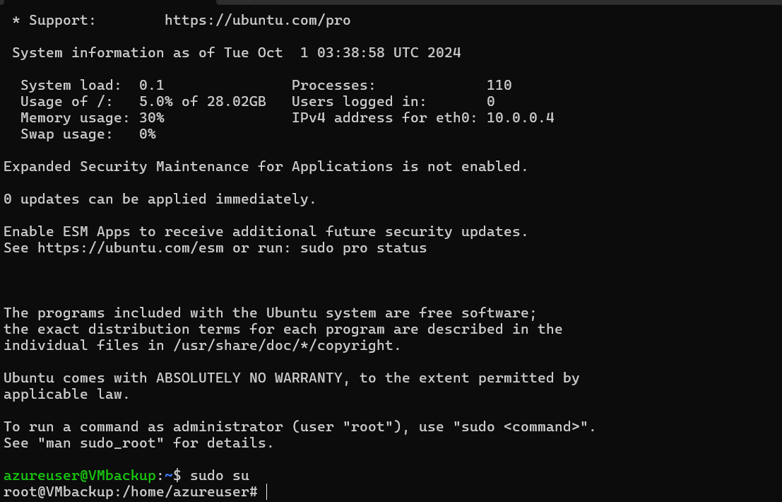

1. **Install Apache 2:**
   * Update the package index:

**sudo apt update**

* + Install Apache 2:

**sudo apt install apache2 -y**

* + Enable and start the Apache service:

**sudo systemctl enable apache2**

**sudo systemctl start apache2**

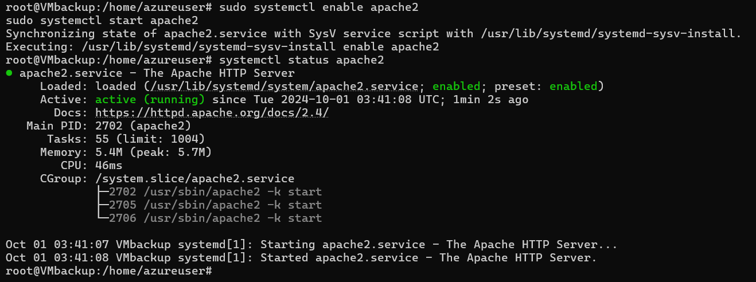

**Task 2: Create Recovery Services Vault**

1. **Create Recovery Services Vault:**
   * In the Azure Portal, click on "Create a resource."
   * Search for "Recovery Services vault" and select it.
   * Click "Create."
   * Fill in the details:
     + **Subscription:** Choose your subscription.
     + **Resource Group:** Select the same or a different resource group.
     + **Vault Name:** Provide a unique name.
     + **Region:** Choose the same region as your VM.
   * Click "Review + Create" and then "Create."

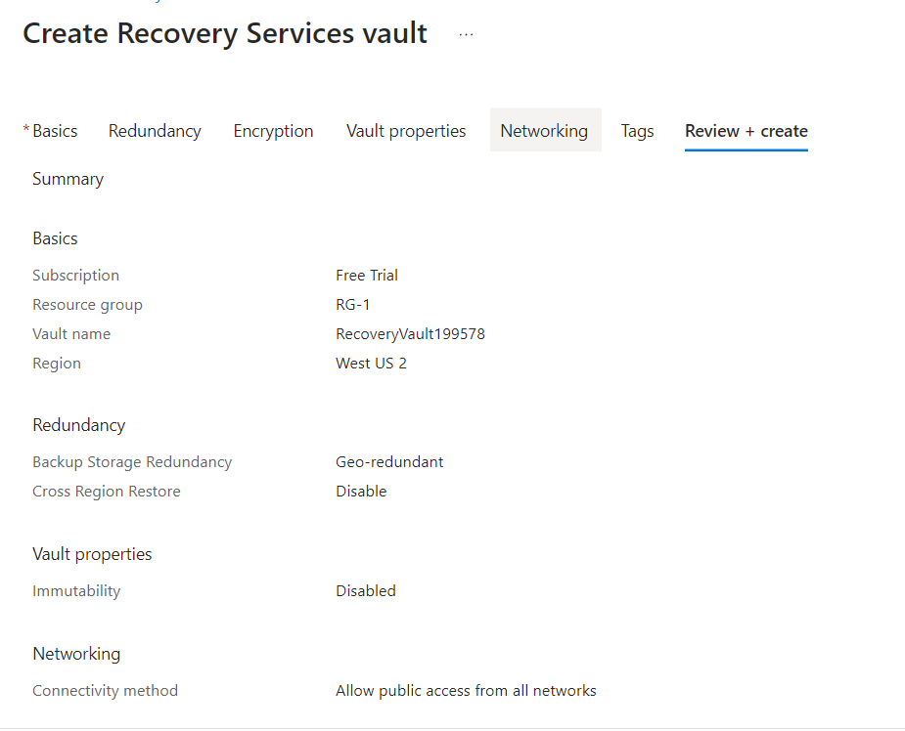

**Task 3: Take Backup of the VM Deployed**

1. **Configure Backup for the VM:**
   * Go to the Recovery Services vault you just created.
   * In the vault, click on "Backup."
   * Choose the following settings:
     + **Where is your workload running?** Select "Azure."
     + **What do you want to back up?** Choose "Virtual machine."
   * Click "Backup" to create a backup policy.

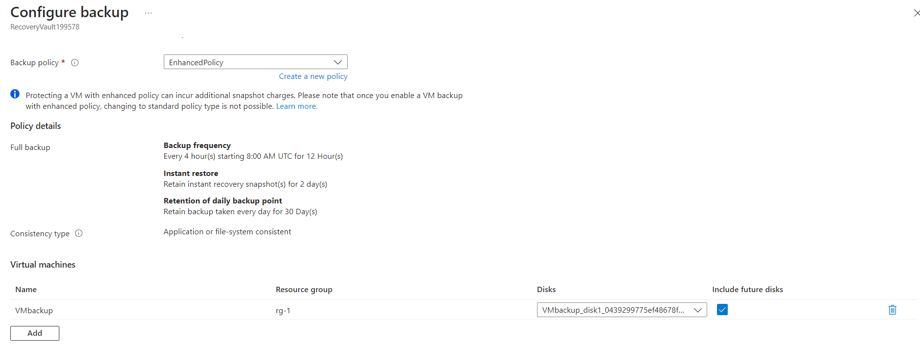

1. **Enable Backup:**
   * In the Backup item configuration, select the virtual machine you want to back up.
   * Choose the backup policy you just created or select the default one.
   * Click "Enable Backup."
2. **Trigger a Backup:**
   * Go to the "Backup Items" under the Recovery Services vault.
   * Click on "Azure Virtual Machine" and select your VM.
   * Click on "Backup now" to initiate an immediate backup.

